**Lab-02**

**To Get familiar with concepts in Python**

# Objectives:

* Learn the basic concepts
* Conditional Statements: If,Else,Elif Statement In Python
* Loops In Python (For Loop ,While Loop Nested Loops In Python

# Apparatus:

* Hardware Requirement Personal computer.
* Software Requirement Anaconda.

# Theory:

## CONTROL STRUCTURES IF ELSE ELIF:

An else statement can be combined with an if statement. An else statement contains the block of code that executes if the conditional expression in the if statement resolves to 0 or a FALSE value.

The else statement is an optional statement and there could be at most only one else statement following if.

## Syntax

The syntax of the if...else statement is − if expression:

statement(s)

else:

statement(s)

## Flow Diagram:

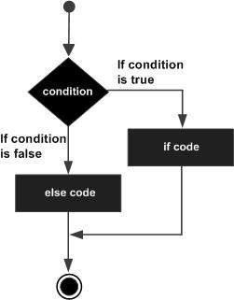

**The elif Statement**

The elif statement allows you to check multiple expressions for TRUE and execute a block of code as soon as one of the conditions evaluates to TRUE.

Similar to the else, the elif statement is optional. However, unlike else, for which there can be at most one statement, there can be an arbitrary number of elif statements following an if.

## syntax

if expression1:

statement(s) elif expression2:

statement(s) elif expression3:

statement(s) else:

statement(s)

Core Python does not provide switch or case statements as in other languages, but we can use if..elif...statements to simulate switch case as follows −

## Demo Code:

#!/usr/bin/python var = 100

if var == 200:

print "1 - Got a true expression value" print var

elif var == 150:

print "2 - Got a true expression value" print var

elif var == 100:

print "3 - Got a true expression value" print var

else:

print "4 - Got a false expression value" print var

print "Good bye!"

## Example: 01

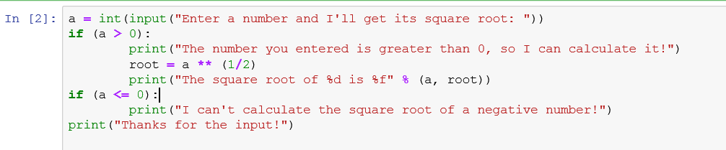Print square root of negative or positive number using if and operators.

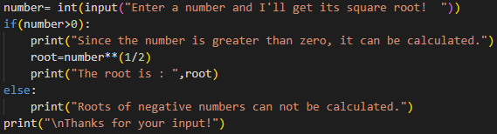

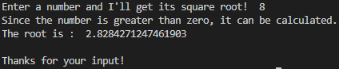

While we are looking at operators, there are another set used in writing conditions, these are

called logical operators. There is an example of a logical operator.

The logical operator used here is the word or. The interpreter evaluates the expressions either side of the **or** operator and if one or the other, or both expressions are true the result is true. There are several logical operators you can use in Python: **and, or, not.**

if country == "England" or country == "england":

Conditions can be composed using two basic logical operators:

|  |  |
| --- | --- |
| **Operator** | **Syntax** |
| Logical AND | And |
| Logical OR | Or |

## Example: 02

Write conditional statements to print value of 0 to 1 and 1 to 0 and numbers in between.

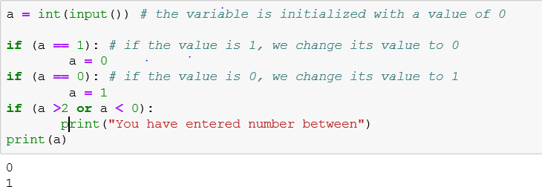

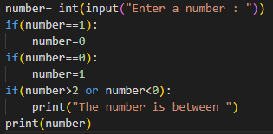



## Example: 03

Let's look at another example:

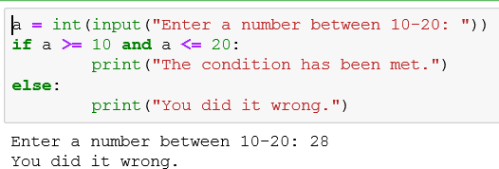

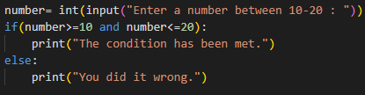



## Example: 04

Of course, operators can also be combined using parentheses:

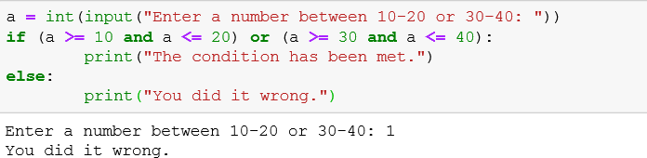

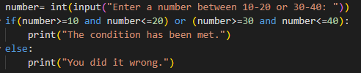



## CONTROL STRUCTURES LOOP

In general, statements are executed sequentially: The first statement in a function is executed first, followed by the second, and so on. There may be a situation when you need to execute a block of code several number of times.

Programming languages provide various control structures that allow for more complicated execution paths.

A loop statement allows us to execute a statement or group of statements multiple times.

## For Loop:

**syntax:**

for iterating_var in sequence: statements(s)

## While - Loop

Syntax:

**1initialization**

**2while (Condition):**

#body of the loop/statement goes here

**3increment/decrement**

## Example #1

Print Karachi Pakistan 100 times in a separate line

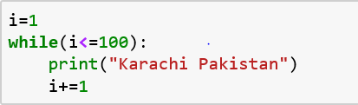

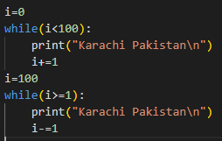

Another way to solve this problem with decrement

operator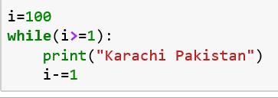

**Example # 2**

Take collection of number input from user. Print the total positive and negative number.

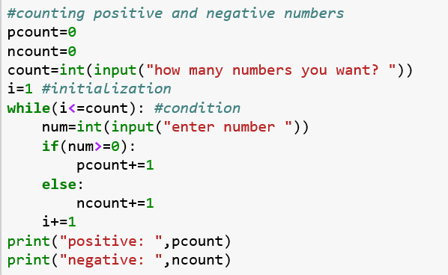

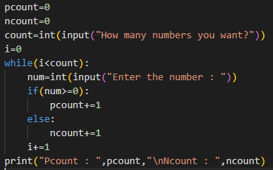

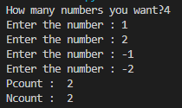

**Example # 3**

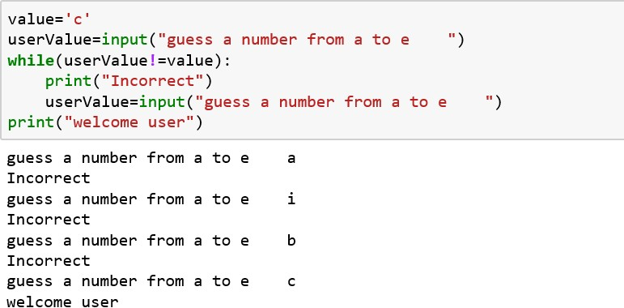Fixed a Letter from a to e and then ask the user to guess that letter until correct letter entered.

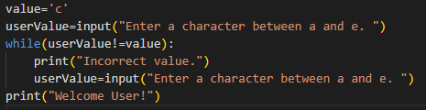

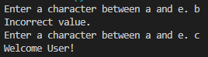

**LOOP TYPE AND DESCRIPTION**

|  |  |
| --- | --- |
| **Sr.No.** | **Loop Type & Description** |
| 1 | [while loop](https://www.tutorialspoint.com/python/python_while_loop.htm)  Repeats a statement or group of statements while a given condition is TRUE. It tests the condition before executing the loop body. |
| 2 | [for loop](https://www.tutorialspoint.com/python/python_for_loop.htm)  Executes a sequence of statements multiple times and abbreviates the code that manages the loop variable. |
| 3 | [nested loops](https://www.tutorialspoint.com/python/python_nested_loops.htm)  You can use one or more loop inside any another while, for or do..while loop. |

# LAB EXERCISES

## Exercise 1:

1. Cabinets and Boxes are objects that are mostly in cubic shape. Make a program that takes inputs like height, width and depth from user and then calculate volume of the cube: volume = height ∗ width ∗ depth

After calculating volume of cube, compare it with following ranges and print the relevant label:

|  |  |
| --- | --- |
| Volume Range | Label |
| 1 cm3 – 10 cm3 | Extra Small |
| 11 cm3 – 25 cm3 | Small |
| 26 cm3 – 75 cm3 | Medium |
| 76 cm3 – 100 cm3 | Large |
| 101 cm3 – 250  cm3 | Extra Large |
| 251 cm3 and  above | Extra-Extra  Large |

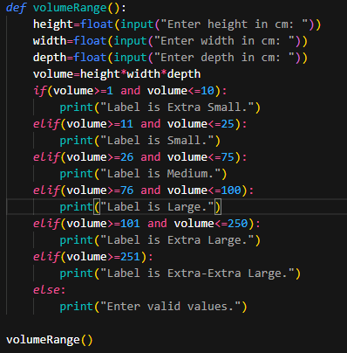 

1. In a company ,worker efficiency is determined on the basis of the time required for a worker to complete a particular job.If the time taken by the worker is between 2-3 hours then the worker is said to be highly efficient. If the time required by the worker is between 3-4hours,then the worker is ordered to improve speed. If the time taken is between 4-5 hours ,the worker is given training to improve his speed ,and if the time taken by the worker is more than 5 hours ,then the worker has to leave the company, If the time taken by the worker is input through the keyboard,find the efficiency of the worker.

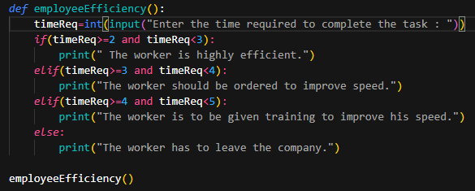



(iii)The program must prompt the user for a username and password. The program should compare the password given by the user to a known password. If the password matches, the program should display “Welcome!” If it doesn’t match, the program should display “I don’t know you.

*Note: the password should not be case sensitive and it’s value is abc$123 or ABC$123*

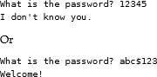

What is the password? ABC$123 Welcome!

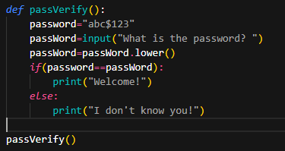 

## Exercise 2:

1. **What Would Python Print?**

>>> n = 3

>>> while n >= 0:

... n -= 1

... print(n)

**The output is: 2 ,1 ,0, -1**

The code block will continue to run until n becomes < 0, since 0 is not greater than or equal to 0.

## : What Would Python Print?

>>> # typing Ctrl-C will stop infinite loops

>>> n = 4

>>> while n > 0:

... n += 1

... print(n)

…

**Output: The code will run infinitely as condition will remain true.**

Make sure your while loop condition eventually becomes false, or it'll never stop!

1. Try the scenario below:

Make a program that lists the countries in the set

clist=['Canada','USA','Mexico','Australia']

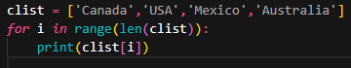 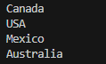

1. Create a loop that counts from 0 to 100

**for i in range(0,101):**

**Print( i )**

1. Make a multiplication table using a loop

**n=int(input("Enter the table number : "))**

**for i in range(1,11):**

**print(n,"x",i,"=",n*i)**

1. Output the numbers 1 to 10 backwards using a loop

**digit=10**

**while(digit>0):**

**print(digit)**

**Digit - = 1**

1. Create a loop that counts all even numbers to 10

**count=0**

**for i in range(11):**

**if(i%2==0):**

**count+=1**

**print(count)**

1. Create a loop that sums the numbers from 100 to 200

**num=100**

**for i in range(100):**

**num=num+i**

**print(num)**

1. Try the exercise below:
2. Make a program that lists the countries in the set below using a while loop.

clist=["Canada","USA","Mexico"]

**clist = ["Canada","USA","Mexico"]**

**i=0**

**while(i<3):**

**print(clist[i])**

**i+=1**

1. What’s the difference between a while loop and a for loop?

ANS: for loop is used when the number of iterations are already known whereas while loop is used when a particular condition is to be proved wrong.

1. Can you sum numbers in a while loop? **YES**
2. Can a for loop be used inside a while loop? **YES**